DANNIEL WORTHEN CULLUMBER

Danniel Worthen Cullumber

Danniel Worthen Cullumber is a trauma therapist, intuitive healer, and doctoral candidate who blends evidence-based practice with culturally grounded and spiritually sensitive healing.

Danniel Worthen Cullumber, MSW, LCSW, is a trauma therapist, intuitive healer, and founder of Willow Medela Wellness LLC. She specializes in trauma recovery, meaning-making, and culturally responsive care for clients whose identities or spiritual experiences don’t fit traditional clinical models. Danniel is a doctoral candidate advancing research on narrative healing and spiritual experiences in trauma. She is frequently featured in national and international media for her expertise in trauma, resilience, and holistic mental health.
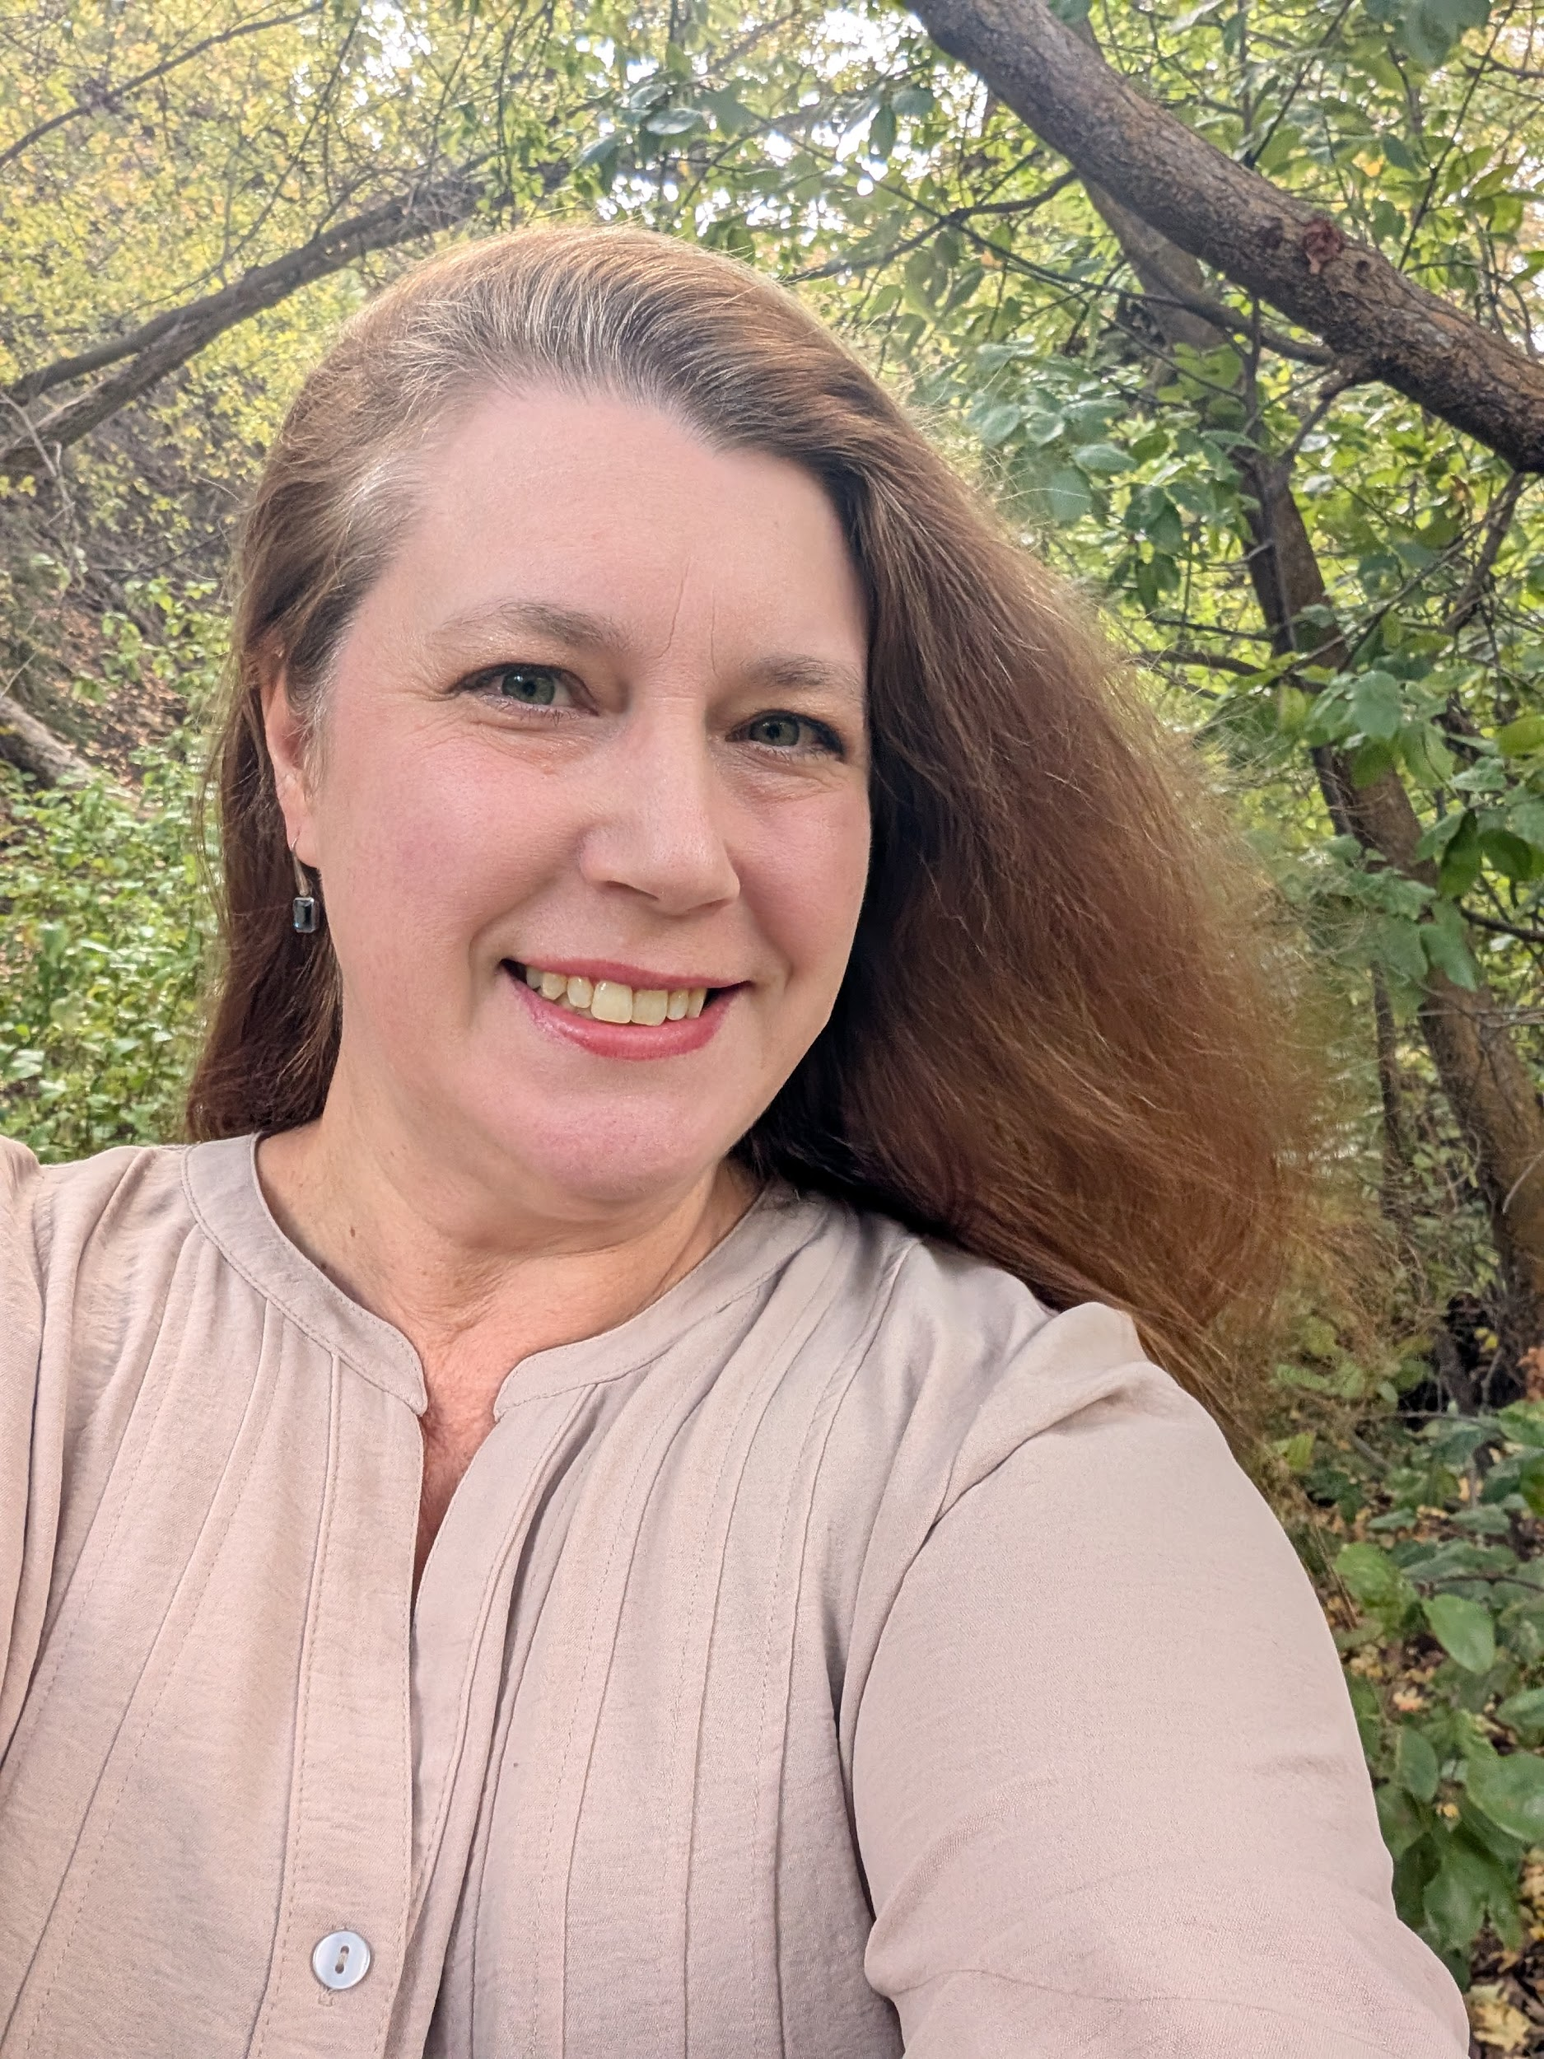

Full Bio

Danniel Worthen Cullumber, MSW, LCSW, is a trauma therapist, intuitive healer, and founder of Willow Medela Wellness LLC, a practice dedicated to integrating clinical trauma care with cultural identity and spiritual meaning-making. With more than two decades of experience in social work, she is known for supporting clients who feel overlooked in traditional mental health systems; particularly those navigating trauma, cultural complexity, and paranormal or intuitive experiences. Danniel blends evidence-based approaches with holistic and Indigenous-informed practices, offering clients a healing model rooted in both clinical competence and spiritual awareness.

She is a doctoral candidate studying narrative therapy, resilience, and spiritually integrated trauma work. Her expertise has been featured in That’s Life! Magazine, Yorkshire Women’s Life Magazine, She Rise Studio, Marquis Who’s Who, and multiple podcasts and media outlets. Danniel is also a sought-after speaker and educator on trauma, decolonizing mental health, women’s emotional liberation, and intuitive wellness.
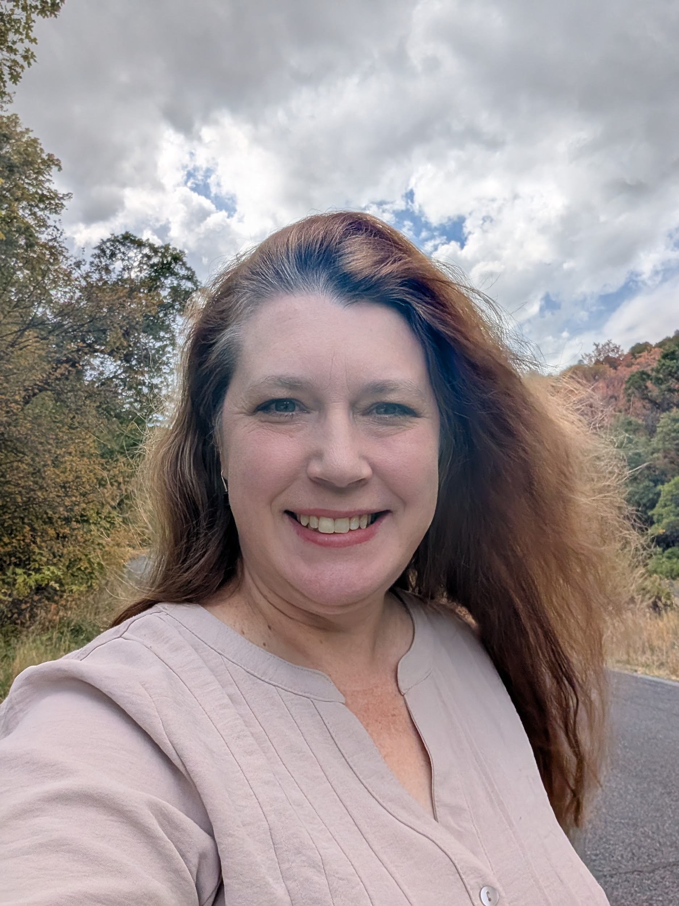

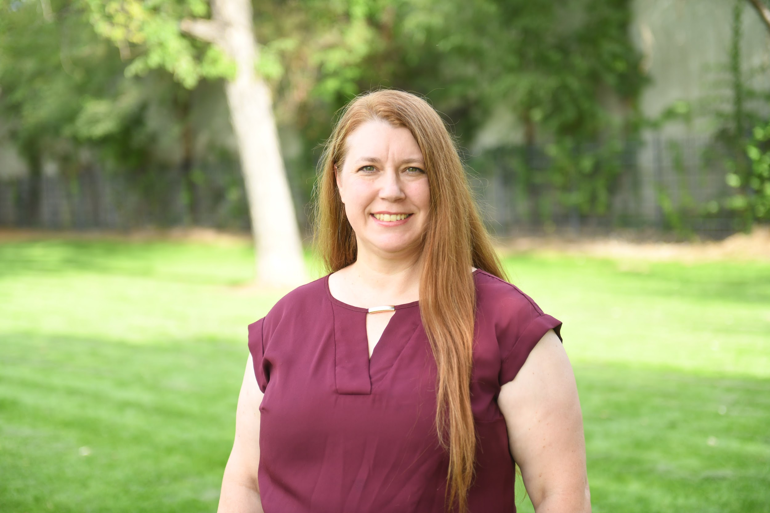

Danniel Worthen Cullumber, MSW, LCSW
Founder | Trauma Therapist | Intuitive Healer | Doctoral Candidate | Speaker

Expertise:
Trauma-informed care; Cultural and spiritual identity in healing; Narrative therapy and meaning-making; Holistic and intuitive practices; Women’s mental health and burnout; Life transitions, grief, and family systems; Spiritual experiences in mental health.
Featured Articles & Publications
- That’s Life! Magazine (Australia)
- Yorkshire Women’s Life Magazine – Health & Wellbeing
- She Rise Studio (“Strength Over Fear”)
- Marquis Who’s Who Honors Release
- Major media coverage including rape trauma commentary
- 90 Percent: Devastating Rape Statistic Will Shock You
Podcasts & Broadcast Media
- Reverse Your Thinking
- Ascended Earth Podcast
- Holistic Healing: Bridging Trauma and the Occult
- Unpacking Mama’s Bag
- Close Up Radio Feature
- Bridging Generations Through Conversation
- In Chat with Danniel (YouTube)
- The Cyclical Doula Podcast

Signature Topics
- Trauma, identity, and resilience
- Healing for spiritually sensitive clients
- Decolonizing mental health
- Boundaries, burnout, and emotional liberation
- Holistic trauma therapy and intuitive wellness
- Integrating clinical practice with Indigenous and spiritual wisdom
Podcast Questions
How do trauma therapy and intuitive work intersect in your practice?
How can spiritual experiences show up during trauma or transition?
What’s one grounding practice listeners can use when feeling overwhelmed?
What’s your ‘spirit reboot’ message for today?

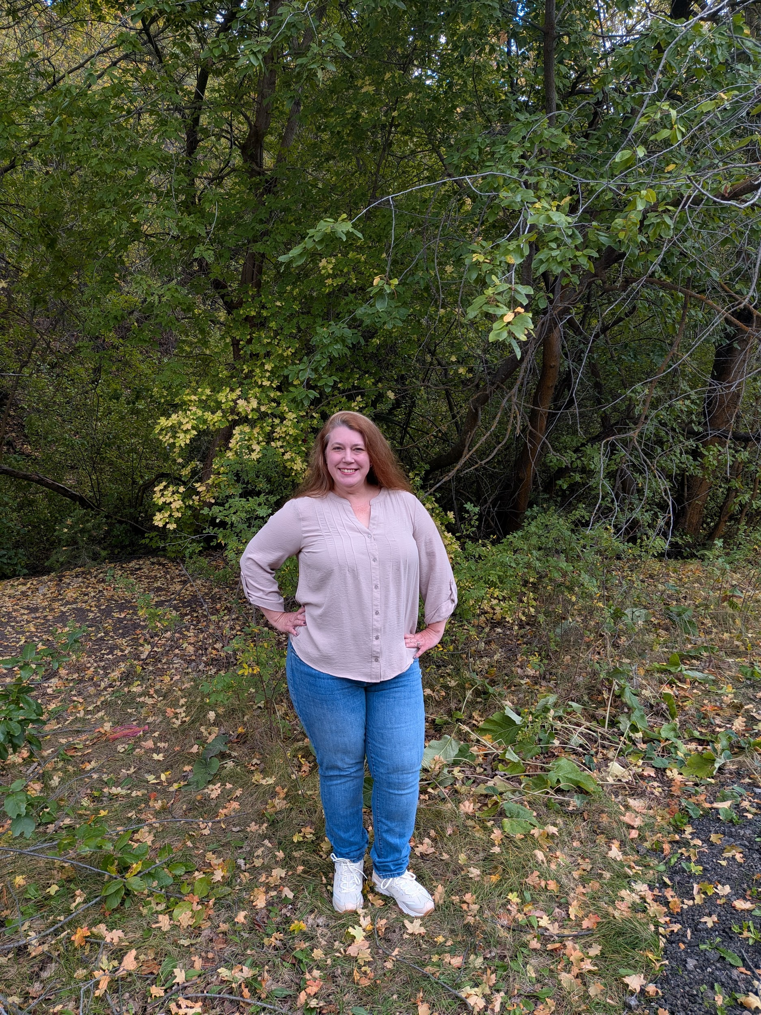
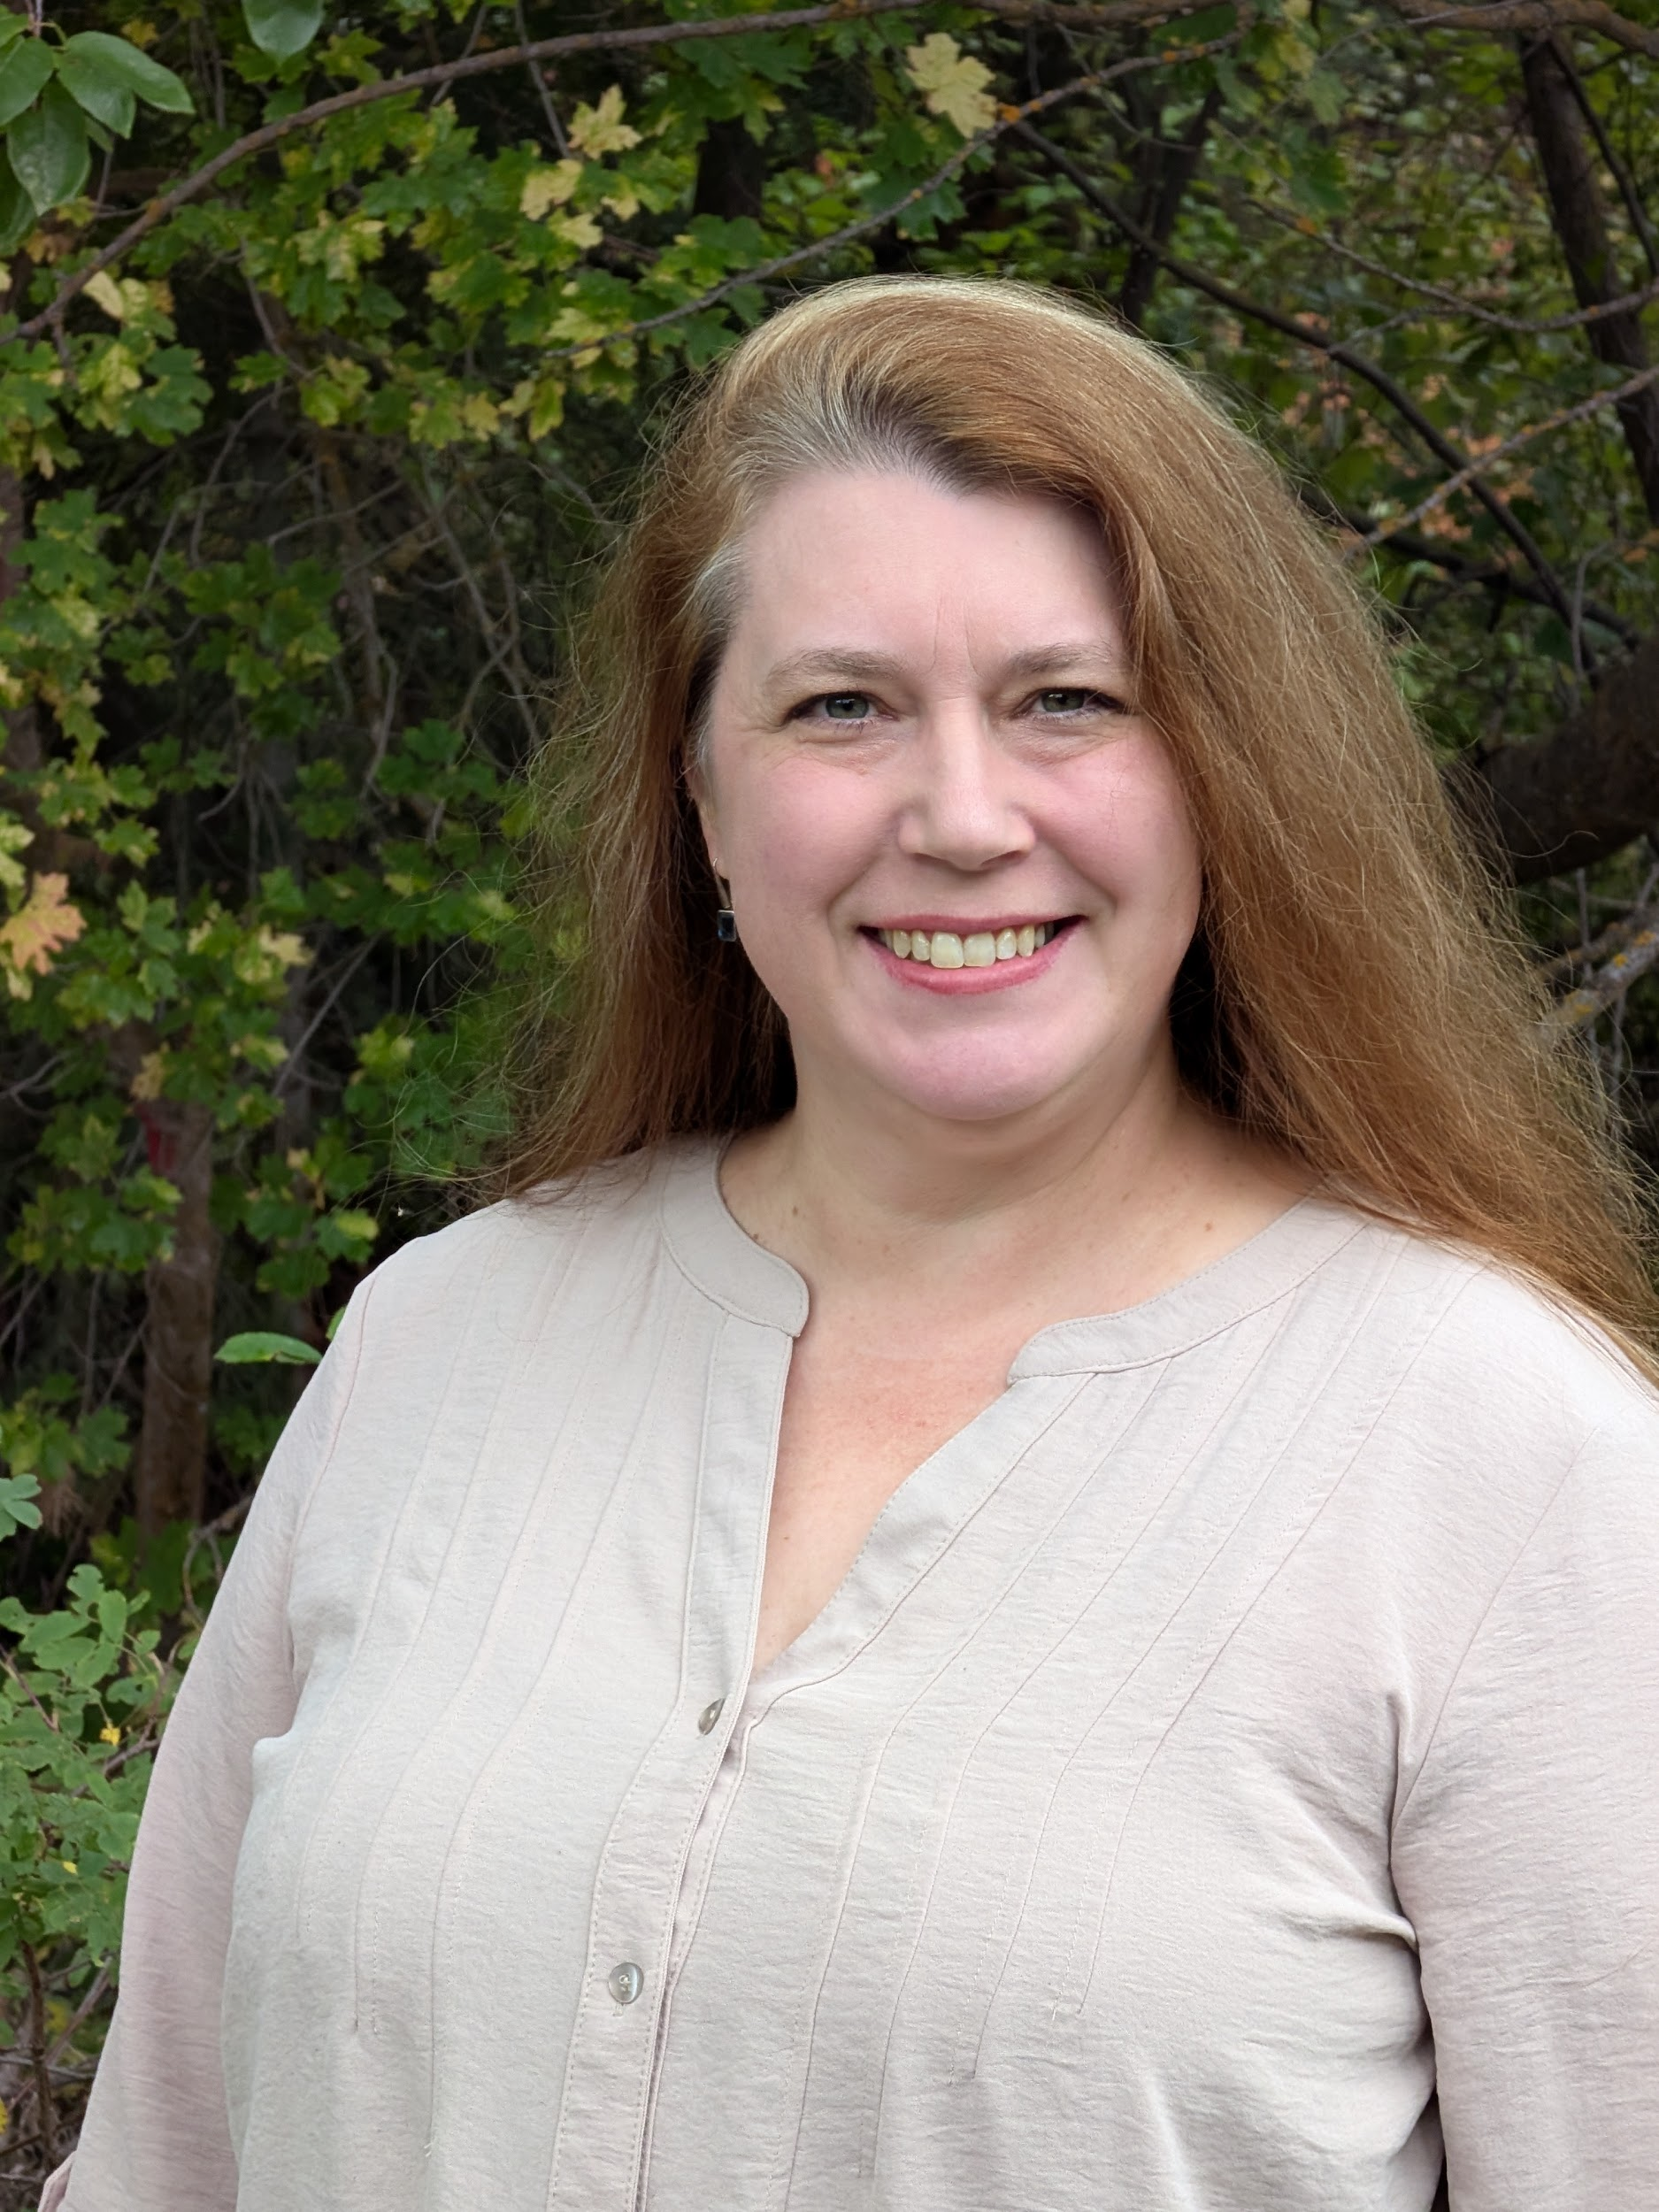

Danniel Worthen Cullumber is a trauma therapist, intuitive healer, and doctoral candidate who blends evidence-based practice with culturally grounded and spiritually sensitive healing.
Contact:
Business: 385-543-4345
WhatsApp: +1-801-906-3802
www.willowmedelawellness.com

info@willowmedelawellness.com

https://linktr.ee/WillowMedelaWellness

www.linkedin.com/in/danniel-worthen-cullumber-l-c-s-w-67b9b88b

https://www.facebook.com/danniel.worthen

https://www.instagram.com/danniel_cullumber/

https://www.threads.com/@danniel_cullumber

